HACKER RANK (JAVA QUESTIONS)

11 . Java int to String
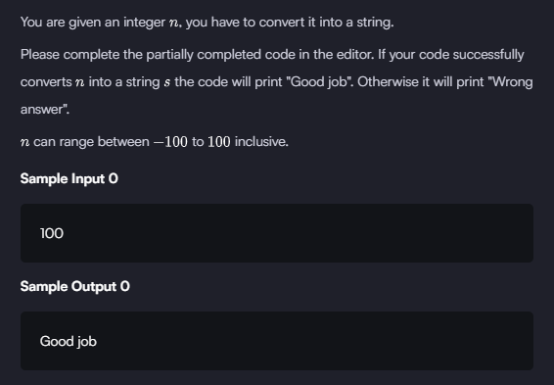

12 . Java Static Initializer Block 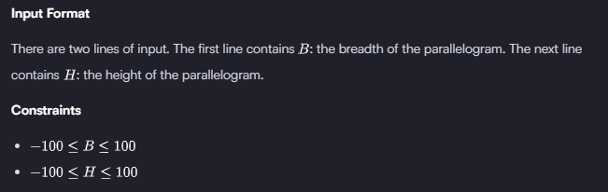
Output Format
If both values are greater than zero, then the main method must output the area of the parallelogram. Otherwise, print "java.lang.Exception: Breadth and height must be positive" without quotes.
Sample input 1
1
3
Sample output 1
3
Sample input 2
-1
2
Sample output 2
java.lang.Exception: Breadth and height must be positive

13. Java Currency formatter
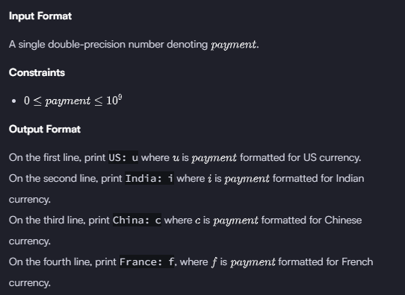
Sample Input
12324.134
Sample Output
US: $12,324.13
India: Rs.12,324.13
China: ￥12,324.13
France: 12 324,13 €

14. Java Strings Introduction
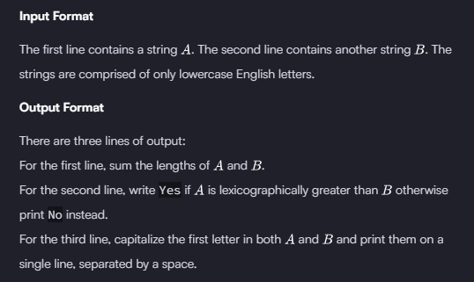
Sample Input 0
hello
java
Sample Output 0
9
No
Hello Java
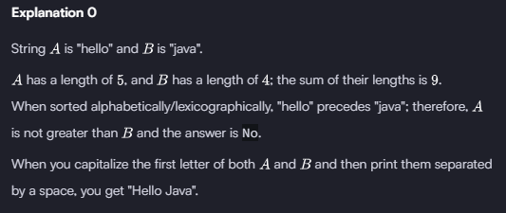
15 . Java Substring Comparison
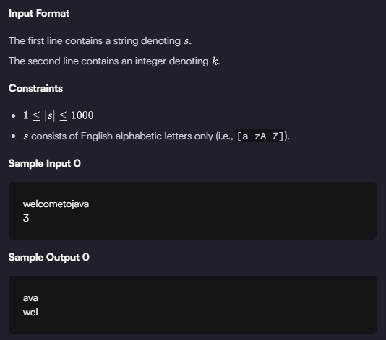
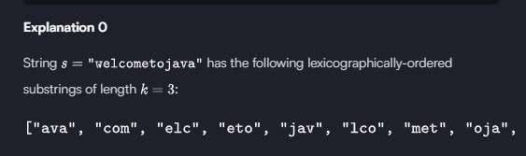
We then return the first (lexicographically smallest) substring and the last (lexicographically largest) substring as two newline-separated values (i.e., ava\nwel).
The stub code in the editor then prints ava as our first line of output and wel as our second line of output.

